**Trigger Email Notification through SNS using Lambda when Object is uploaded to S3**

**STEP 1: CREATE AN S3 BUCKET**

→ Create a bucket with a name and keep other options as default and click on create bucket.

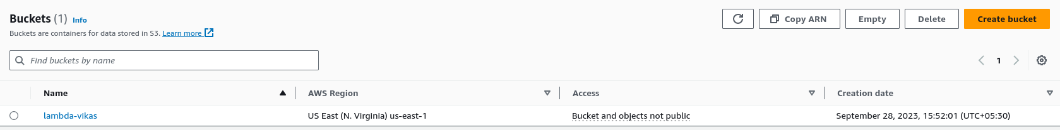

**STEP 2: CREATE AN SNS TOPIC AND SUBSCRIPTION**

**→** Search for SNS and click on Create topic.

→ Select **Standard** type, give a name to the topic and click on create topic.

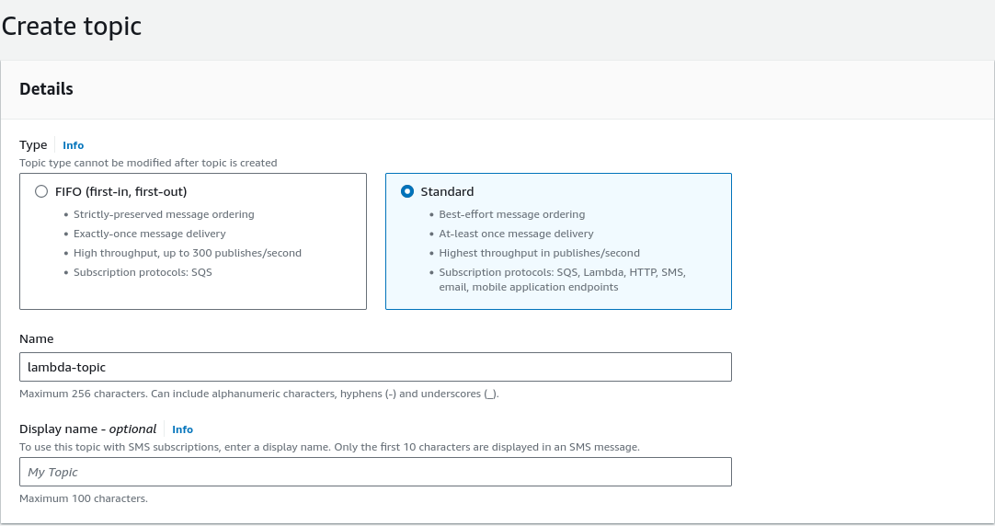

→ Create a subscription for the topic by selecting the Topic ARN in the drop down.

→ Select the **Email** as the protocol and **Endpoint** as the email address to get notifications.

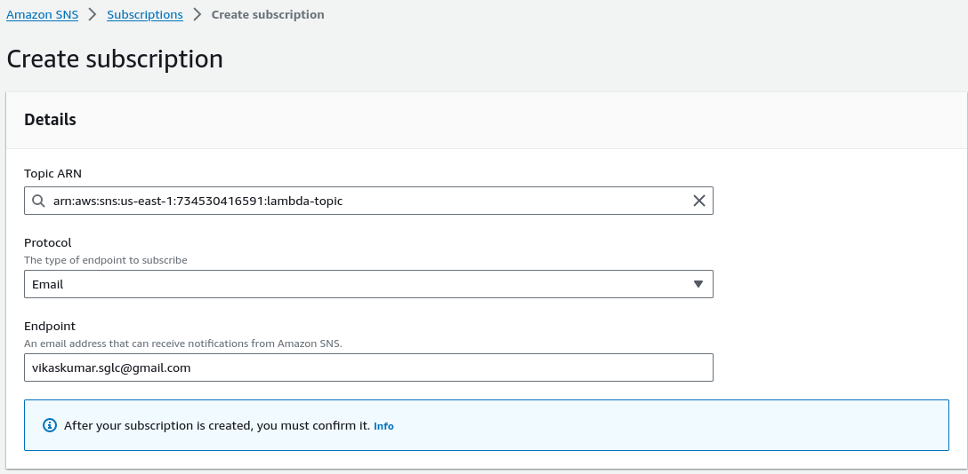

→ Confirm the subscription by clicking on confirmatio link in the mail given.

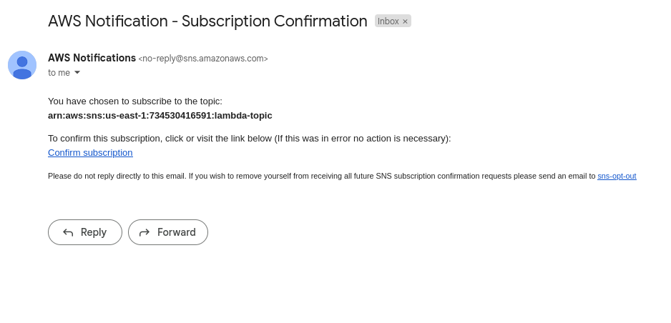

**STEP 3: CREATE A LAMBDA FUNCTION**

**→** Search for lambda service and click on create function.

→ Choose runtime as python 3.10 or any version which is latest.

→ Under permission, select “ **Create a new role with basic Lambda permissions “** and then select create function.

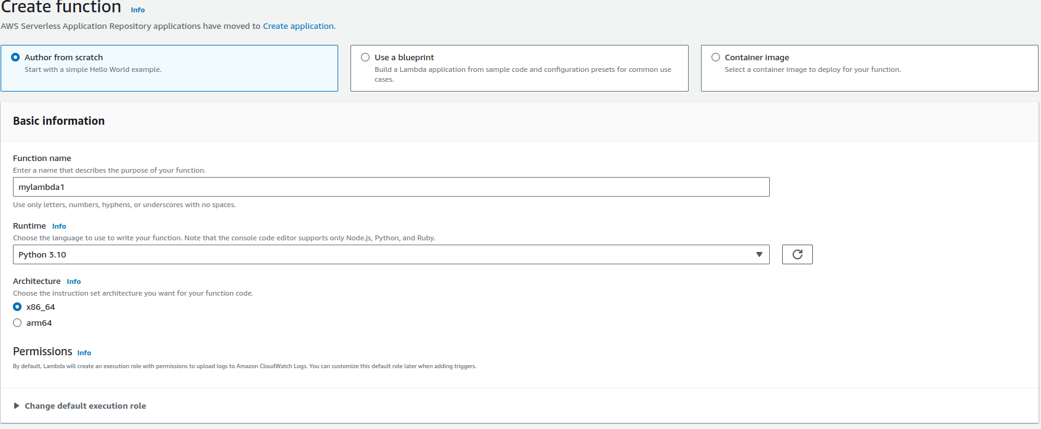

→ Click on the function and go to configuration.

→ Click on the **role name** link and open the IAM role.

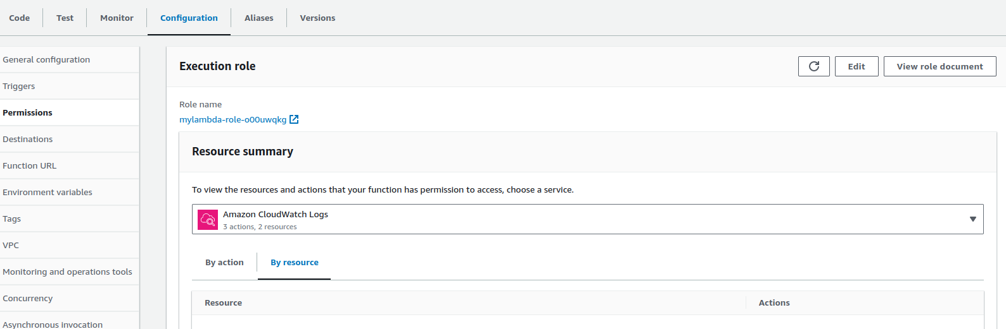

→ Add these policies to the lambda role:

* AmazonS3FullAccess
* AmazonSNSFullAccess



→ Add the following code inside the lambda function:

import json

import boto3

def lambda_handler(event, context):

sns_topic_arn = 'arn:aws:sns:us-east-1:734530416591:lambda-topic'

s3_bucket = event['Records'][0]['s3']['bucket']['name']

s3_object_key = event['Records'][0]['s3']['object']['key']

message = f"Object {s3_object_key} was uploaded to bucket {s3_bucket}"

sns_client = boto3.client('sns')

sns_client.publish(

TopicArn=sns_topic_arn,

Message=message,

Subject='S3 Object Upload Notification'

)

return {

'statusCode': 200,

'body': json.dumps('Notification sent successfully')

}

→ Make sure to add the ARN of the topic created in the lambda handler function.

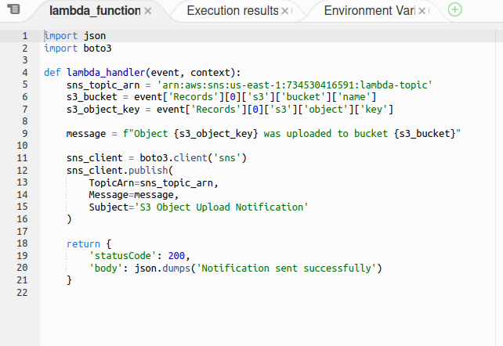

**STEP 4: Configure S3 Bucket Event Trigger**

**→** Go to configuration and click on Triggers section.

→ Click on **Add Trigger** and select the bucket.

→ Under **Event Types** , select **All object create events.**

**→** Tick the box at the bottom and click on **Add**.

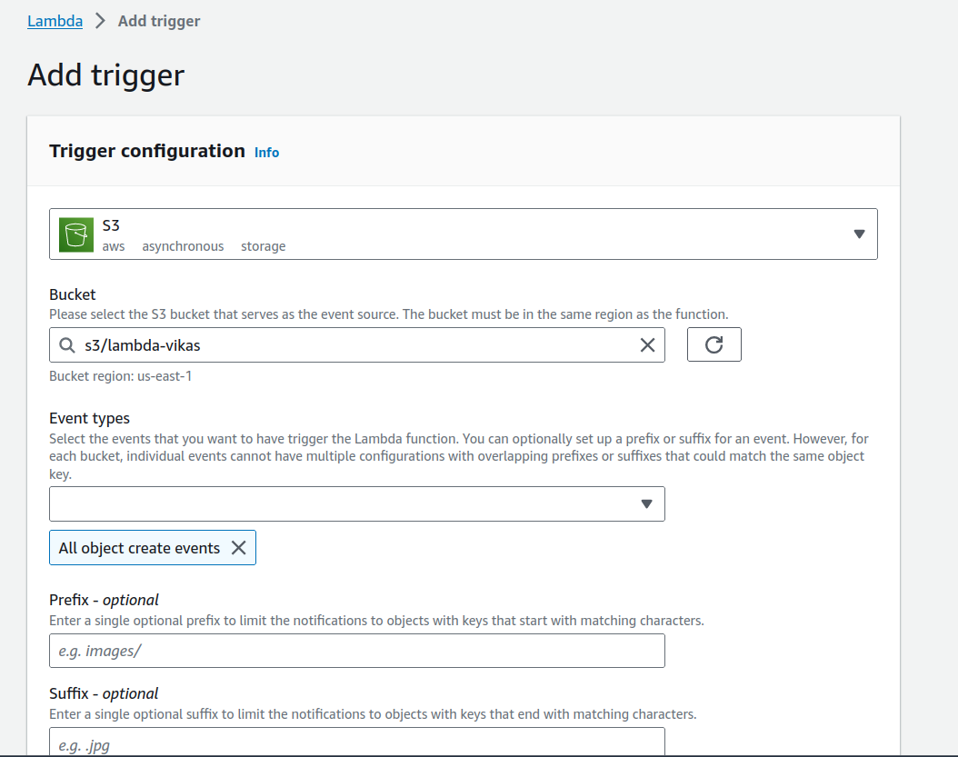

**STEP 5: Trigger Object Creation Event**

→ Go to S3 bucket and add an object to it.

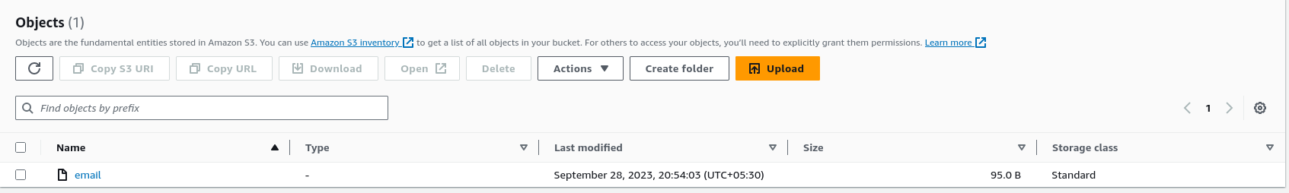

→ After adding the object,check for the the notification in email for adding object.

→ A notification will be triggered for uploading an object to S3.

